AWS_KALKEESHWARA_P_PROJECT_02_ELB&ASG

Course: Working with EC2, ELB, ASG, Cloudwatch

Learning Outcomes  
1. Using Bootstrap script to install and configure EC2  
2. Be able to create Load Balancer and Target group  
3. Register targets under Load Balancer  
4. Create a launch configuration  
5. Able to create auto scaling group

How to do it?

1. Create an EC2 instance with Amazon Linux AMI with Bootstrap

Script  
2. Host the default web server with public IP  
3. create a Load balancer with target group and add manual instance  
4. Host with ELB DNS name  
5. Create Launch configuration with Bash script  
6. Create Auto scaling group from launch configuration  
7. Hit the ELB and state the observations

Create an EC2 instance from the EC2 Services as shown below.  
Search for “EC2” and open the **EC2** services as shown below  
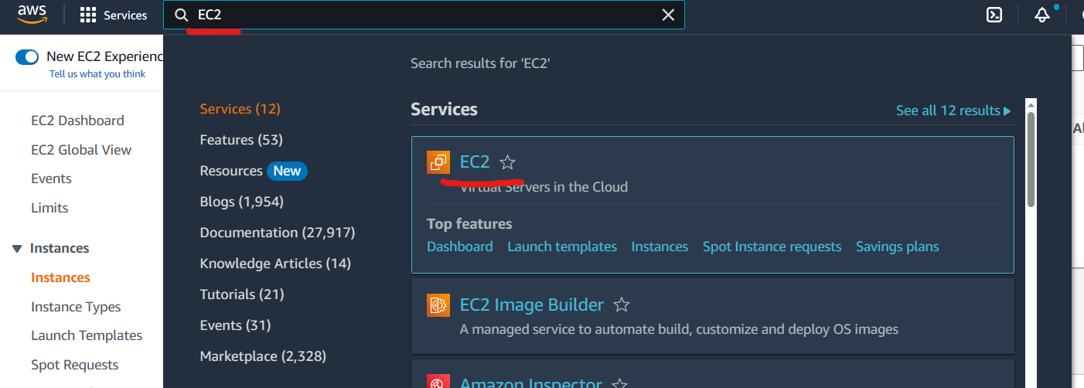

Click on **instance** menu and click on **Launch instance** button.  
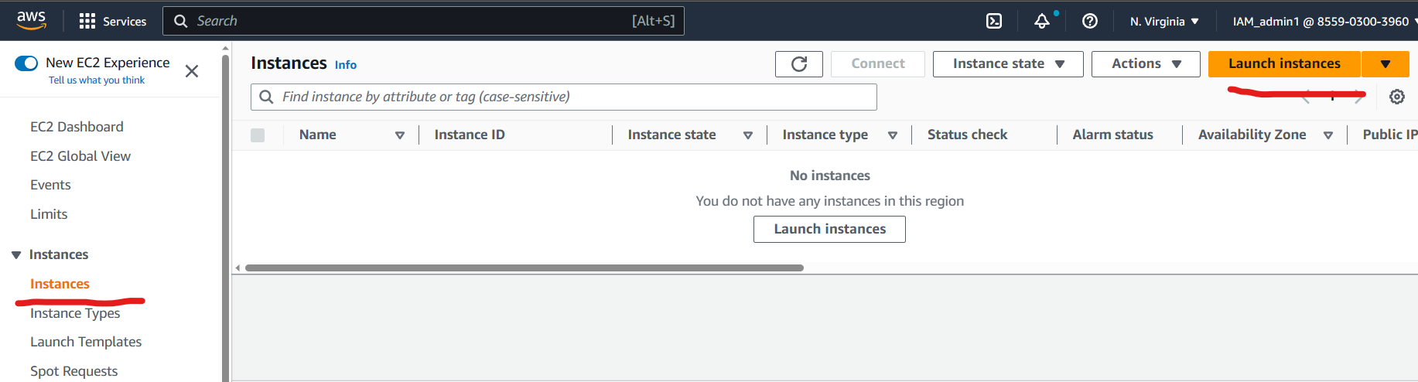

Fill the name as “Manual_instance” in the name field and select the “Amazon Linux 2 AMI” as shown below.  
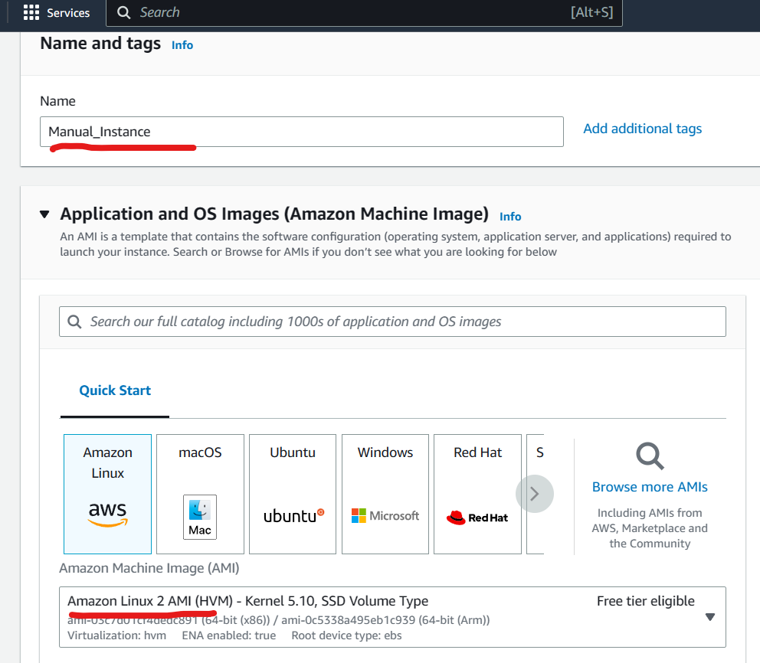  
  
Select “Proceed without a keypair” as shown bwloe.  
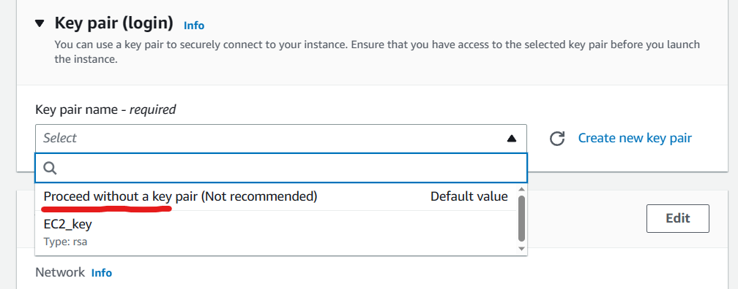

In the Network setting section.  
uncheck the “Allow SSH traffic” and tick mark the “Allow HTTP traffic” as shown below  
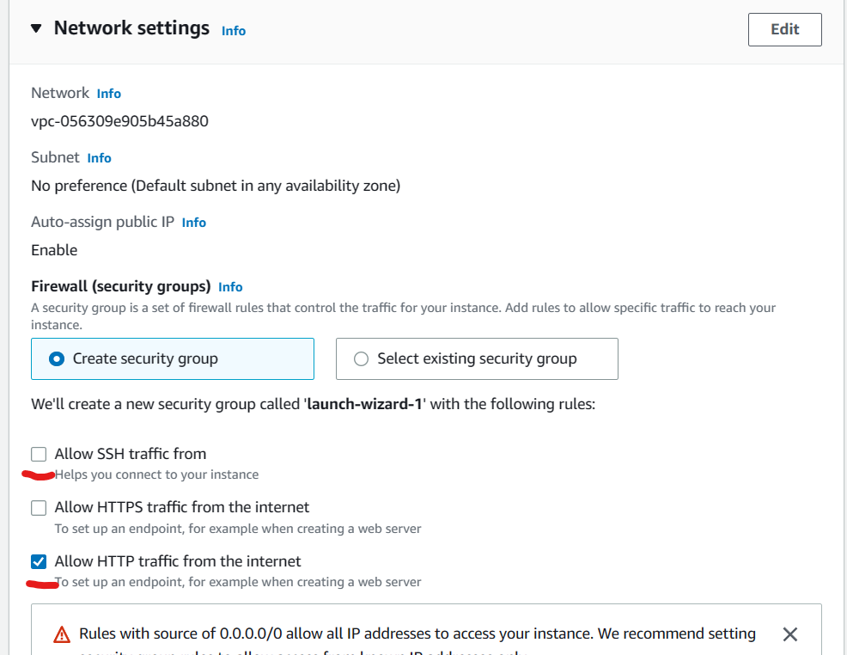  
Open “Advanced Details” section and scroll to the bottom.  
Copy paste the bellow Commands in the user data field as shown below.

#!/bin/bash  
yum update -y  
yum install httpd -y  
service httpd start  
chkconfig httpd on  
IP_ADDR=$(curl http://169.254.169.254/latest/meta-data/public-ipv4)  
echo "AutoScaling instance with IP $IP_ADDR" > /var/www/html/index.html

echo "ok" > /var/www/html/health.html  
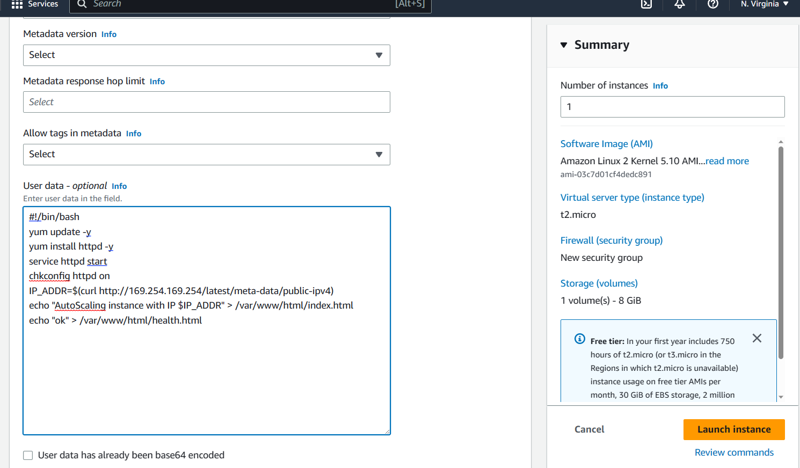  
Click on **Launch Instance**

Now to create a Load Balancer.  
To create a Load balancer visit the **Load Balancer** menu in the EC2 services as shown below.  
Open the Load balancer menu and click on **Create Load Balancer**   
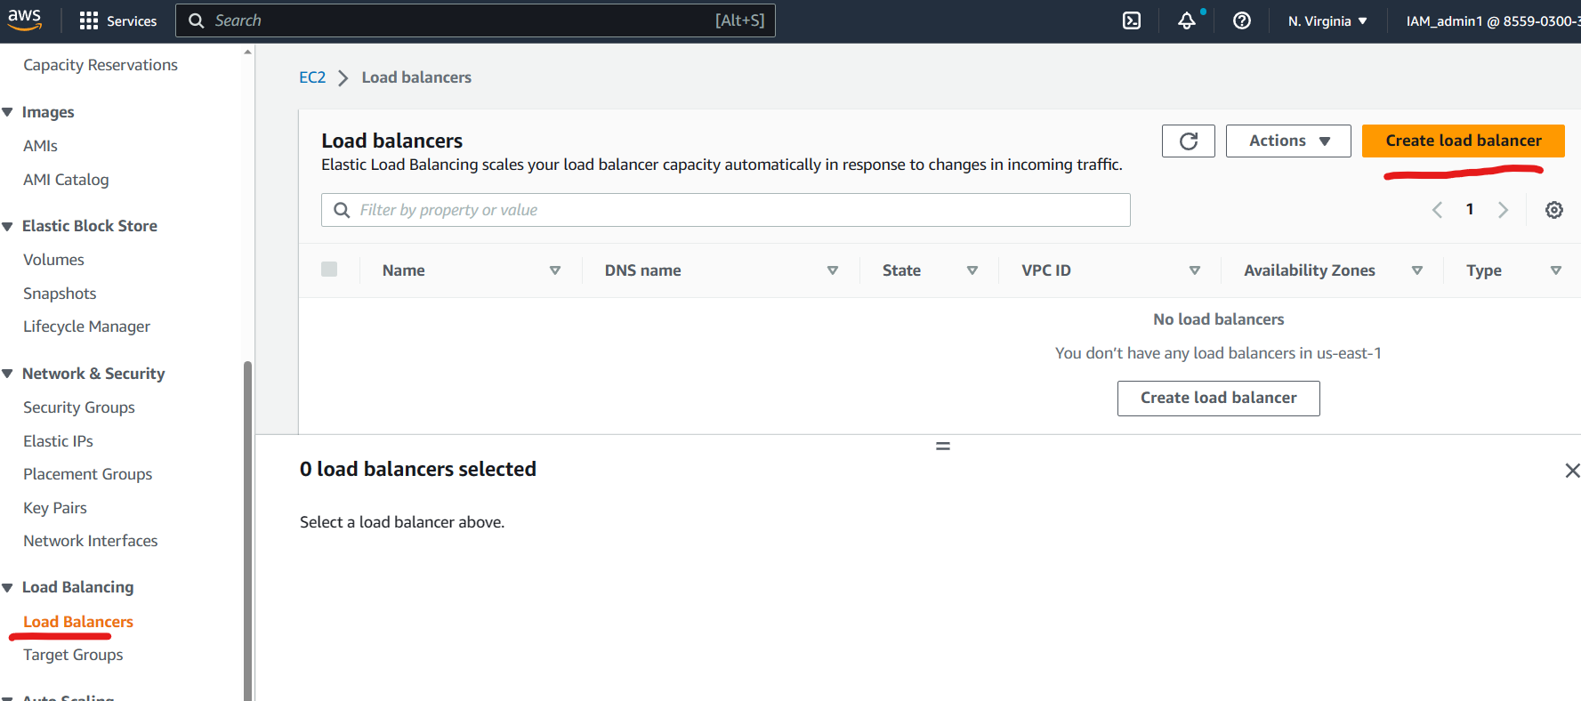  
Click on **Create** under “Application Load balancer” as shown below.  
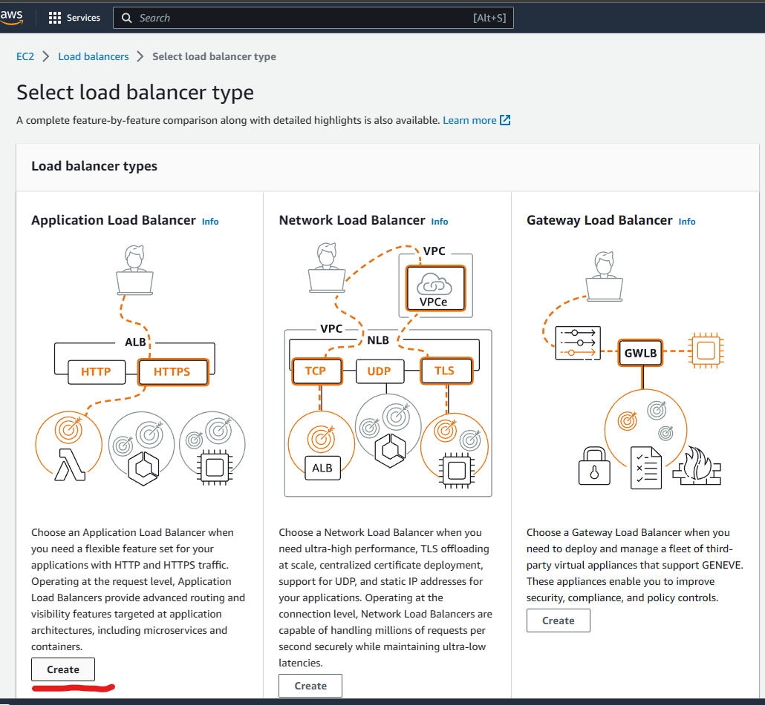

A new page name “create Application Load Balancer” would appear.  
fill in the Name field as “LB”  
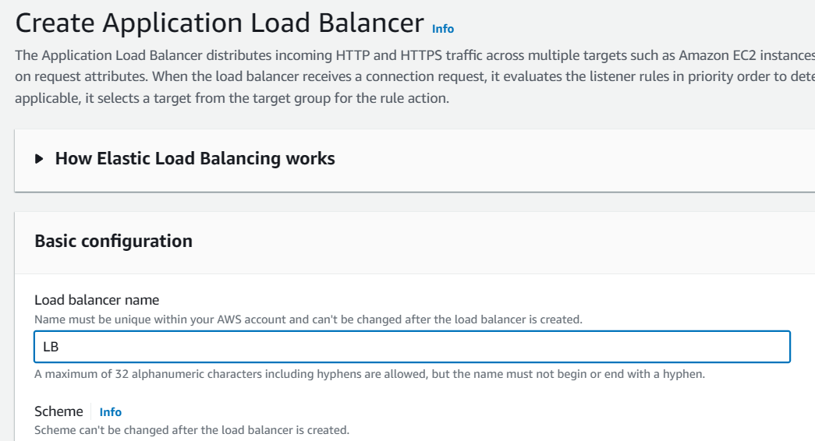  
Scroll down to Network settings.  
Select the default VPC in “VPC” option.  
Tick mark all the availability zone as shown below.  
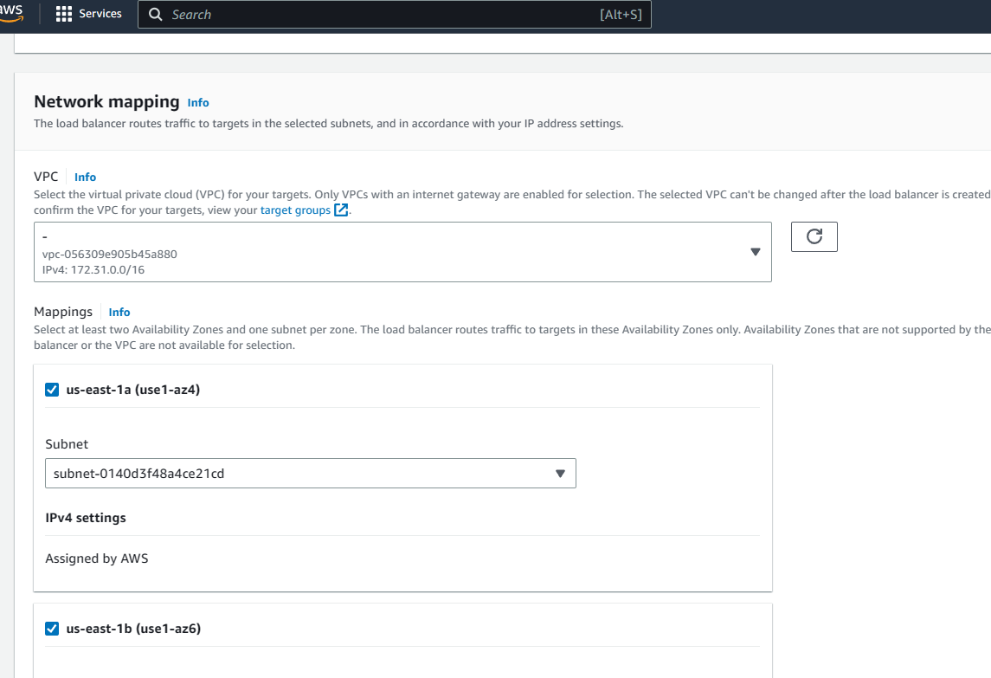

Under security group options.  
remove the default security group and create a new security group for the load balancer.  
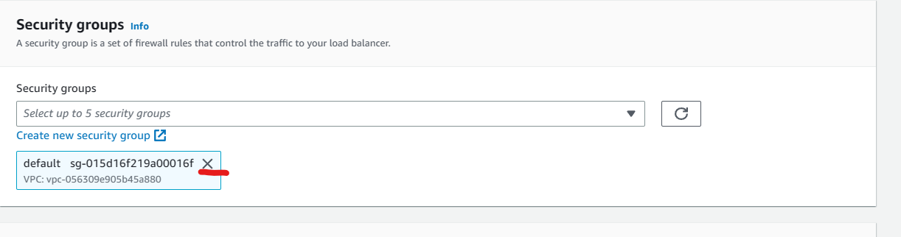  
Click on “create new security group” hyperlink and a new create security group page would appear.  
Fill in the name of Security group as “LB_SG”  
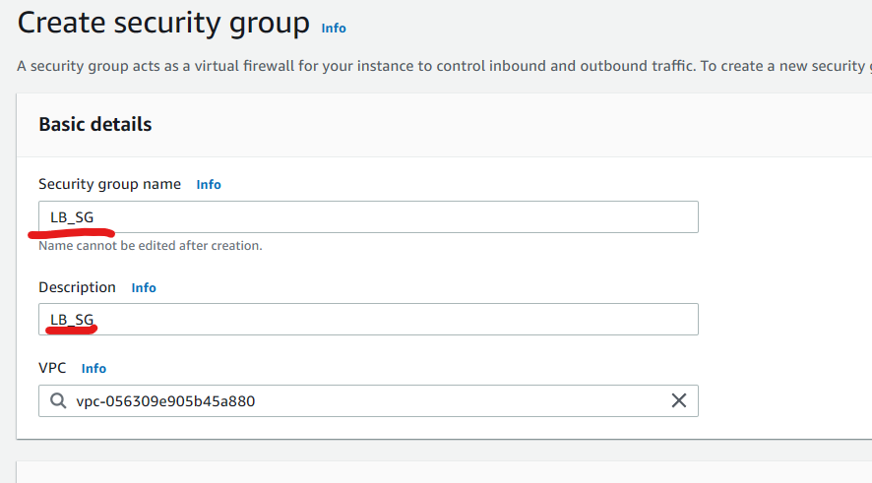  
Scroll down to inbound traffic and click on **Add rule** button.  
select Type as “HTTP” and source as “Anywherre IPv4” as shown below.  
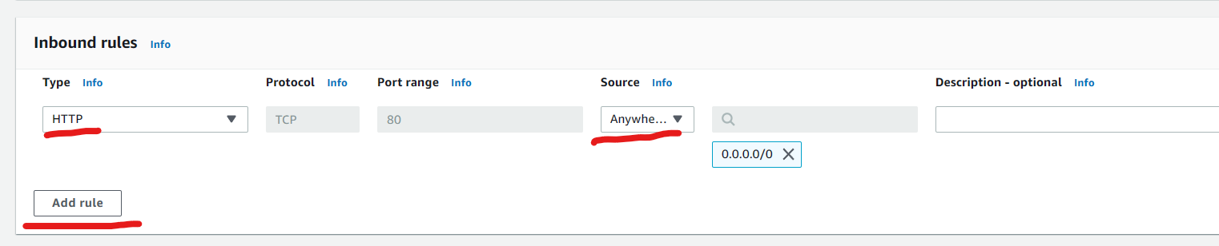  
Scroll down and click on create button.  
Switch back to the previous tab where the load balancer form is open.  
Select the newly created security after refreshing the field.  
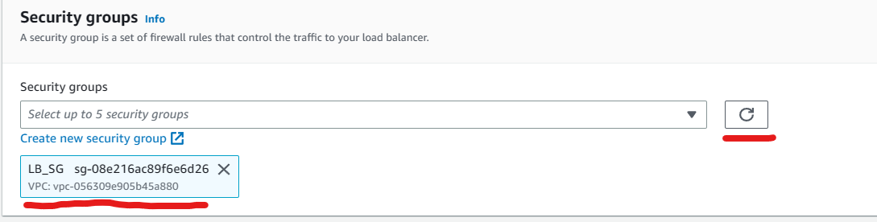  
Scroll down to Listerner group and click on target group as shown below. 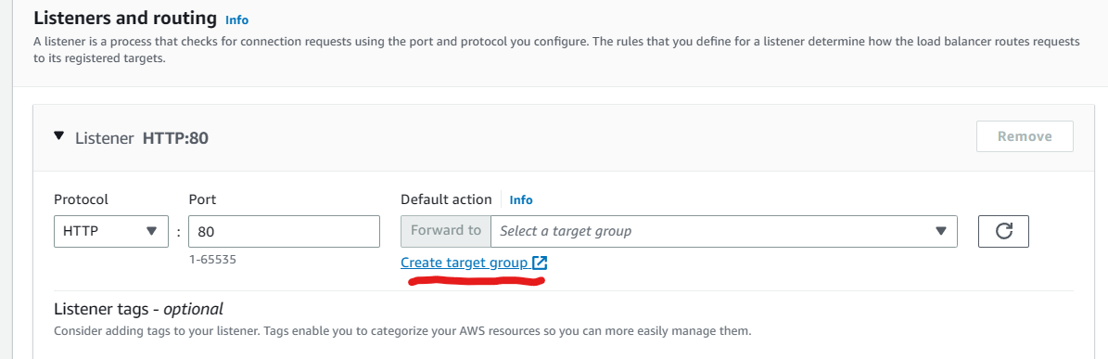

A “Specify Group details” page would appear.  
Set target type as “instance” and fill in a name in the name field.  
  
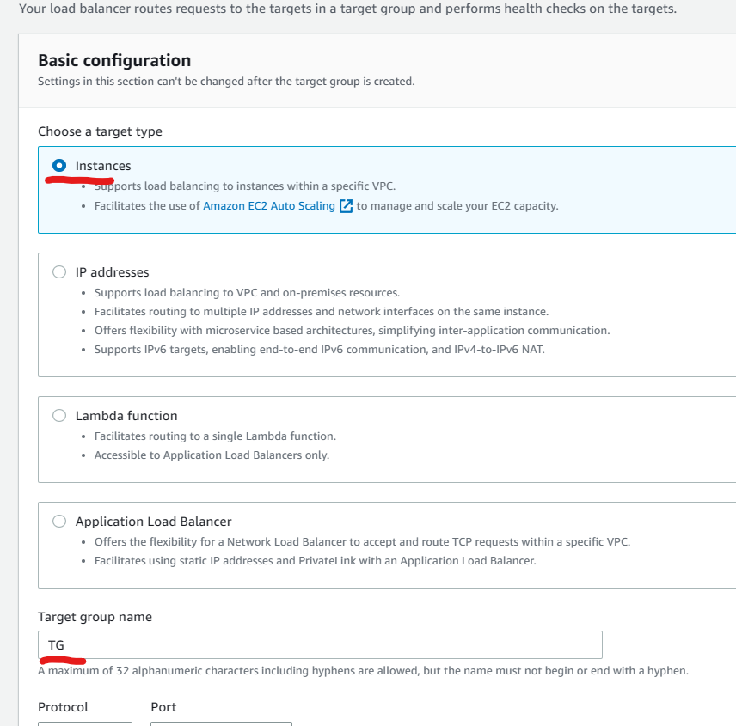  
Scroll to the Health check section and fill in “health.html” in the health check path as shown below.  
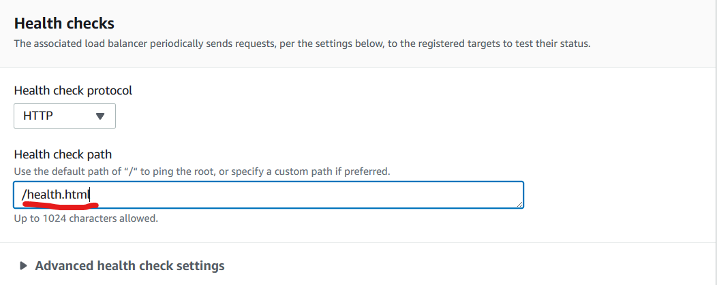

Click on advanced health check settings   
set Healthy threshold as “2” and interval as “6”  
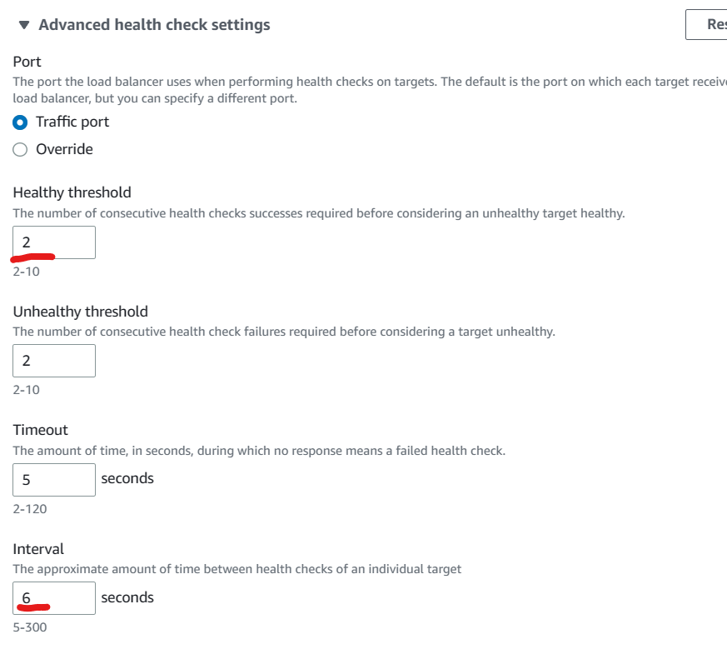

Scroll down and click on next.  
Select the newly created Manual instance as shown below.  
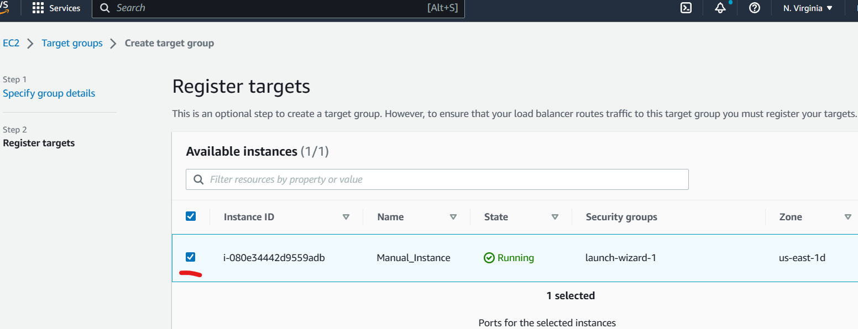  
Scroll down and click on **Create Target group**  
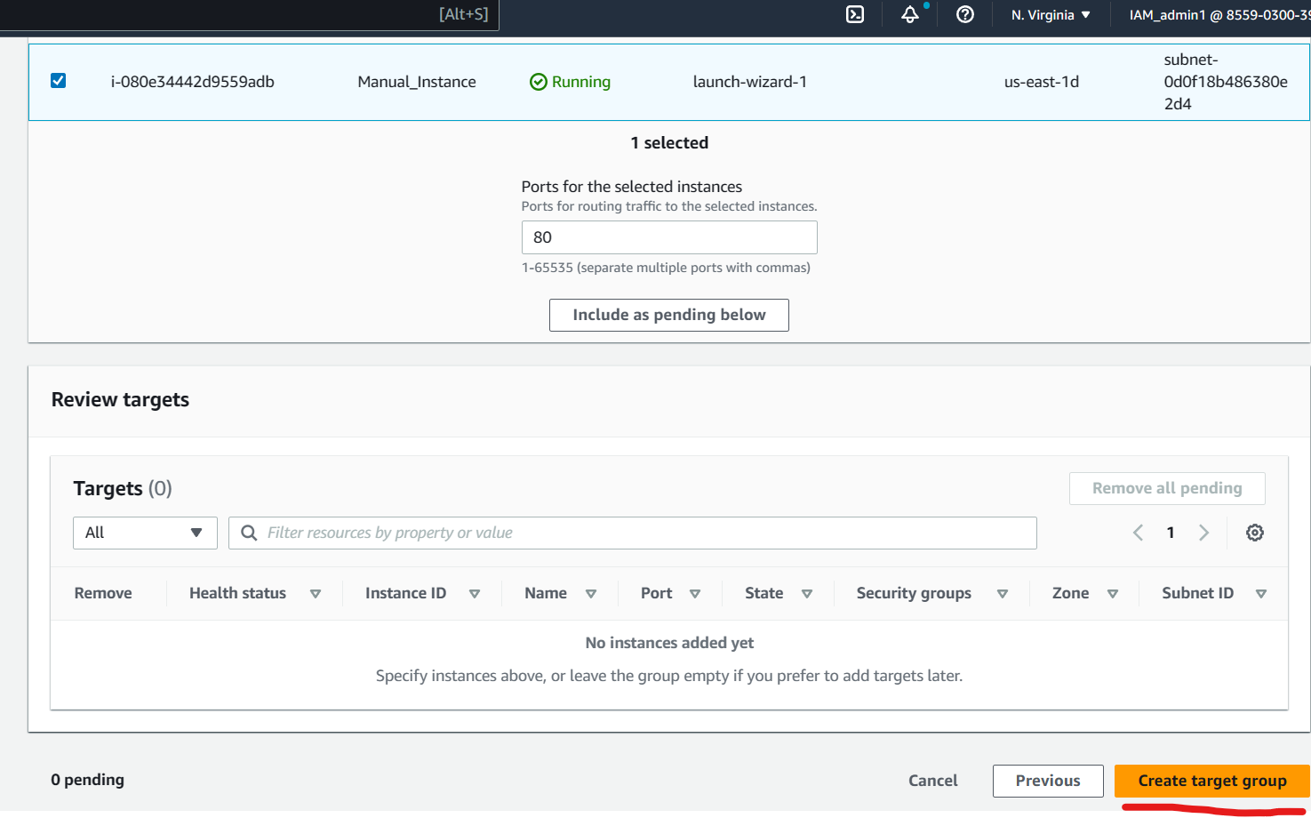Switch back to the Load balancer tab and click on refresh button near target group field.  
Select the newly created target group.  
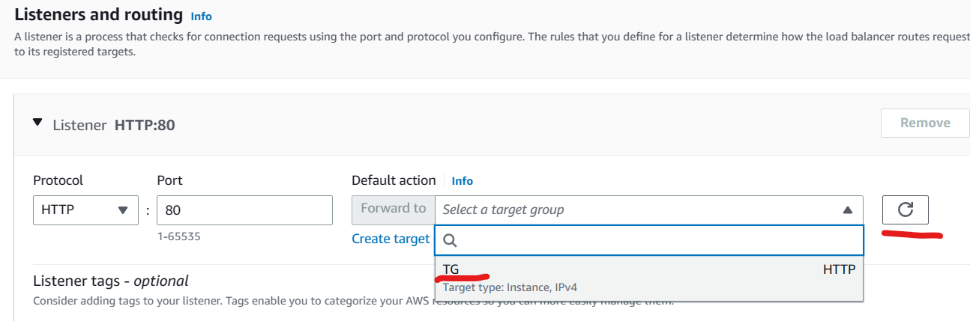  
Scroll down to the bottom and click **Create Load Balancer** button.  
Congratulations you have successfully created a Load balancer.  
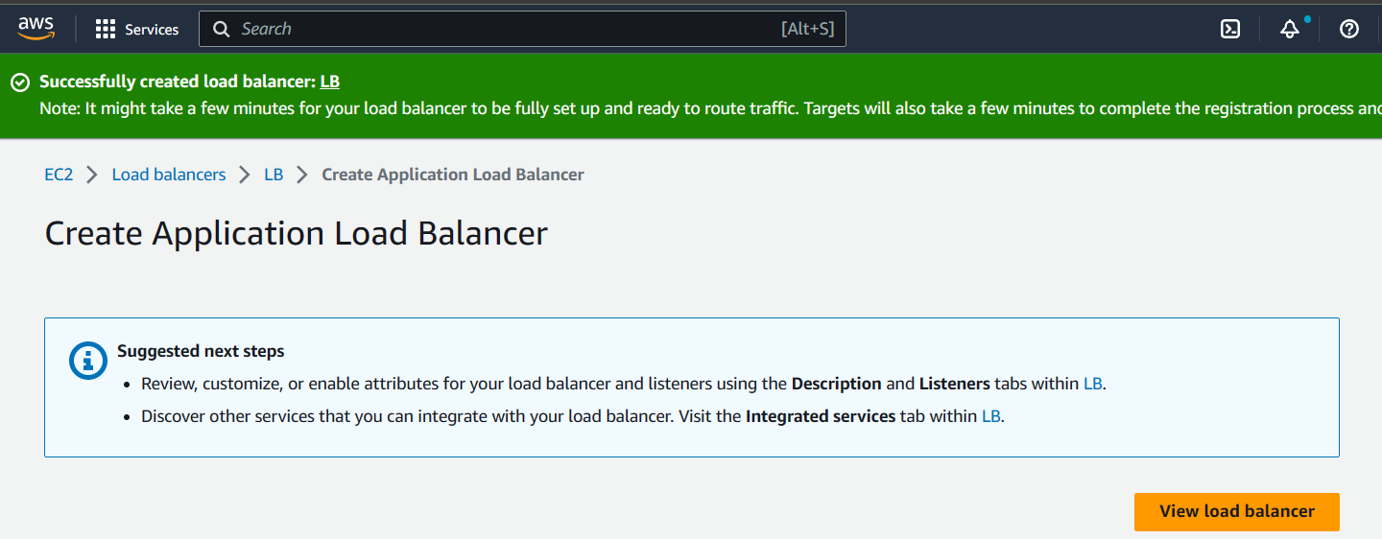

Visit the Target menu and make sure that the instance you have tagged in the target group shows as Healthy as shown below.  
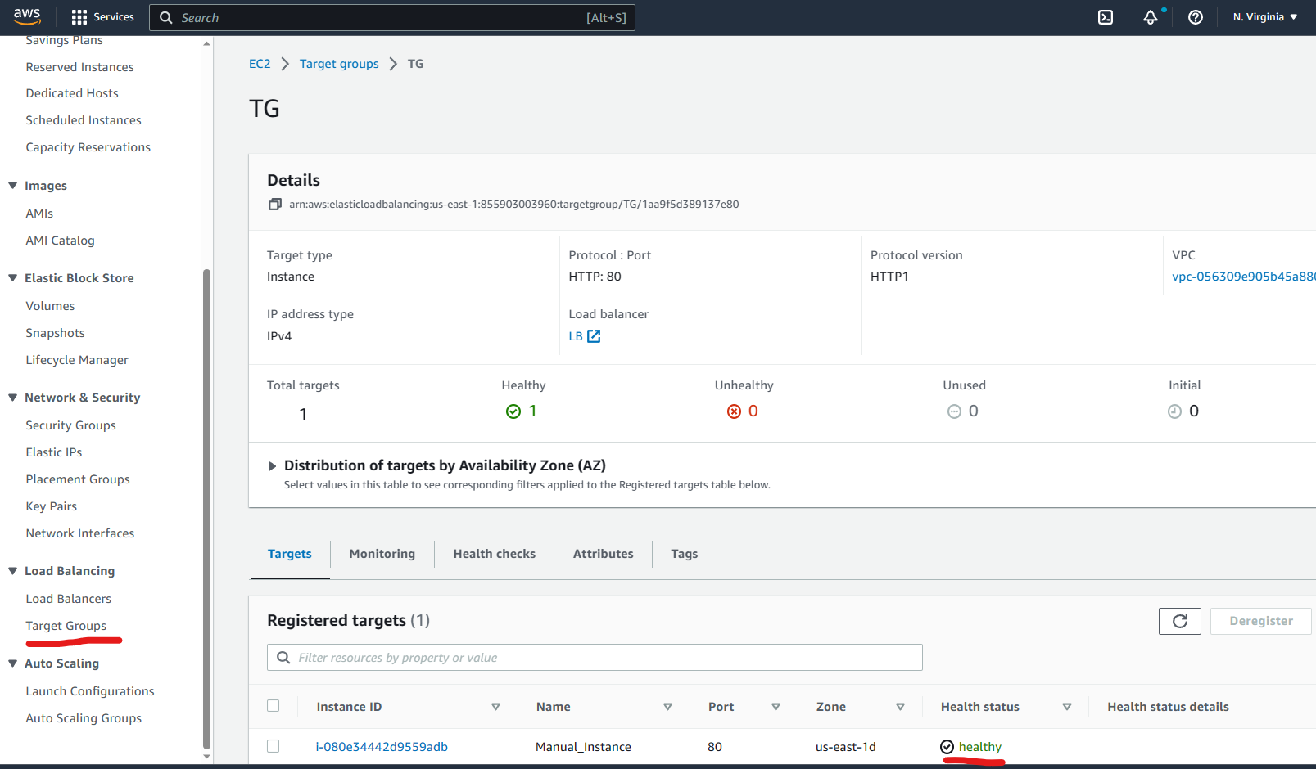

Now visit the Load balancer menu and copy paste the DNS address on the browser search bar and click on enter.  
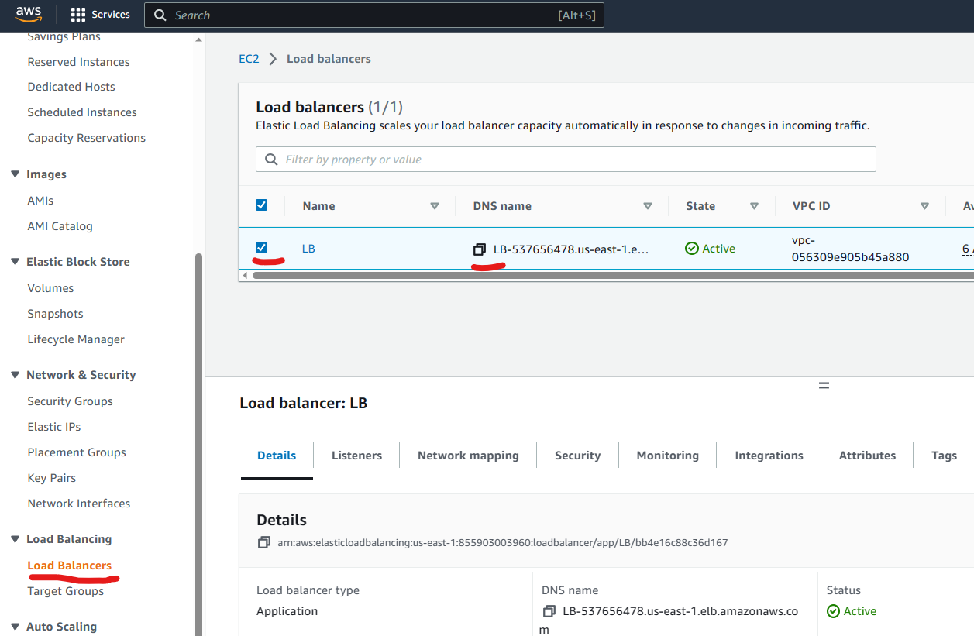  
you will get an output as shown below.  
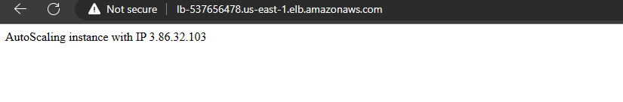

Now to create a Launch Template  
Visit the **Launch Template** and click on **Create Teamplate** button as shown below.  
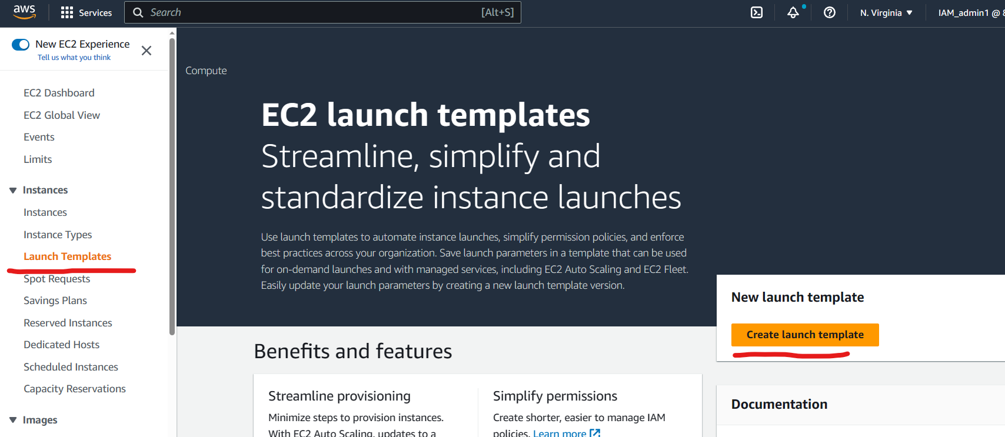  
Fill in the Name field and Description field.  
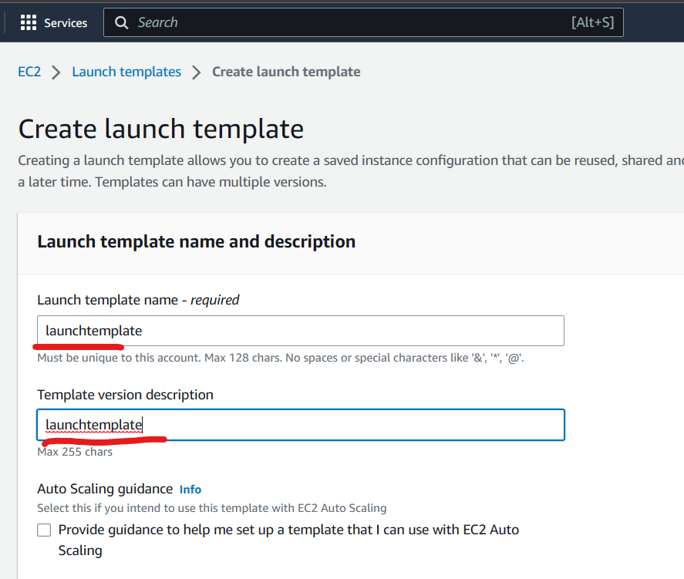  
Scroll down to “Application and OS Images” option and click on **Quick start**   
and select Amzon linux 2 AMI as shown below.  
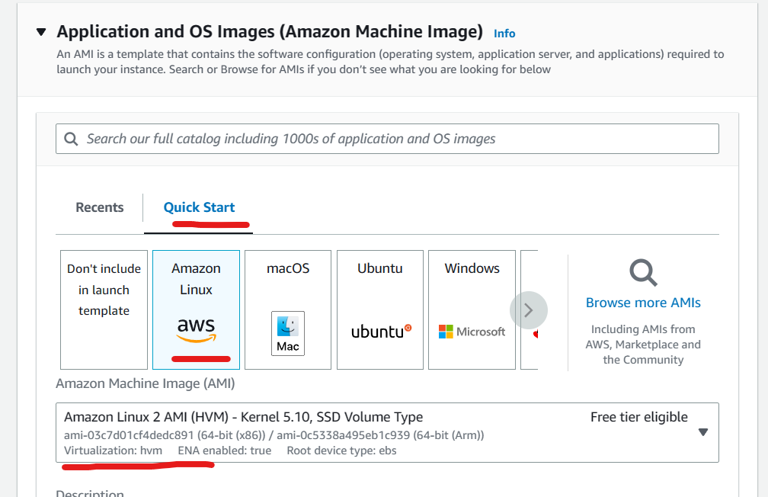

Select Instance type as t2-micro as shown below.  
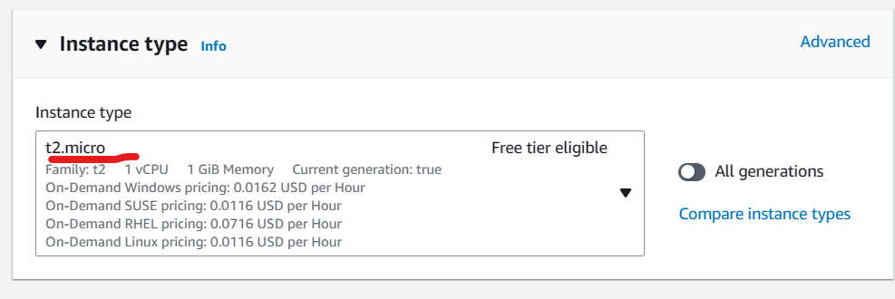  
Set Keypair as “proceed without a key pair”  
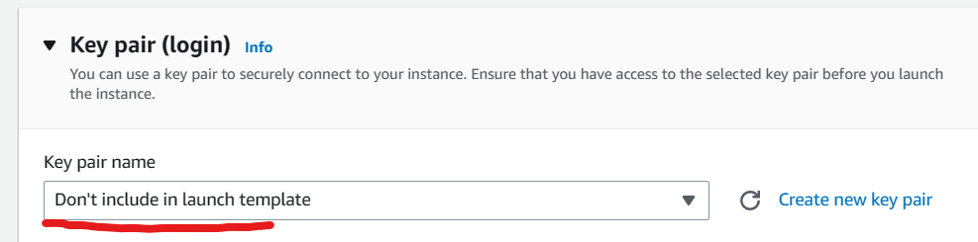  
Under Network Settings.  
Select “Create a security group”  
Fill up the Security group name and description as shown below and click on add security group.  
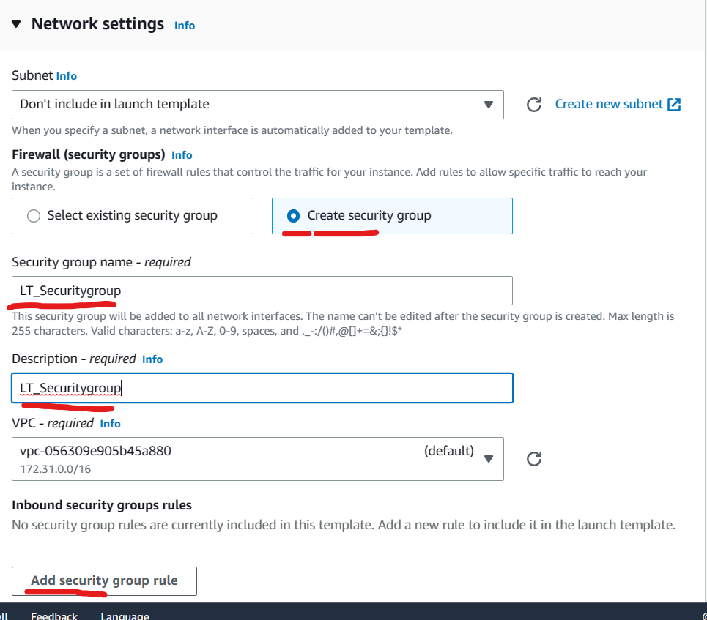

Set type as HTTP and source as anywhere.  
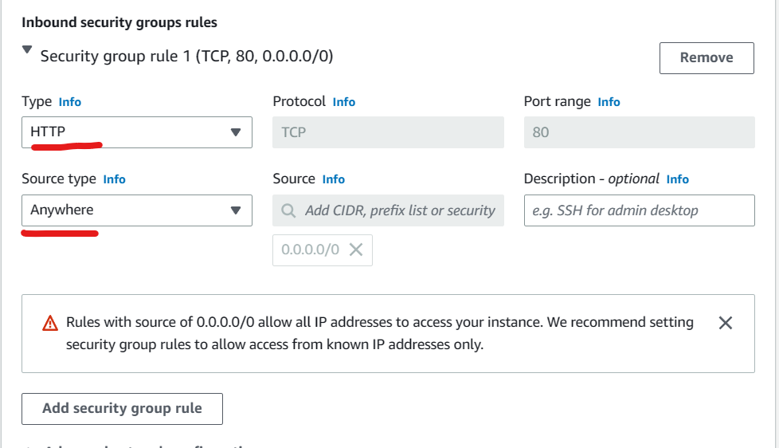

Scroll down to “Adcanced Details” and copy paste the below commands in the user data field.  
#!/bin/bash  
yum update -y  
yum install httpd -y  
service httpd start  
chkconfig httpd on  
IP_ADDR=$(curl http://169.254.169.254/latest/meta-data/public-ipv4)  
echo "AutoScaling instance with IP $IP_ADDR" > /var/www/html/index.html  
echo "ok" > /var/www/html/health.html

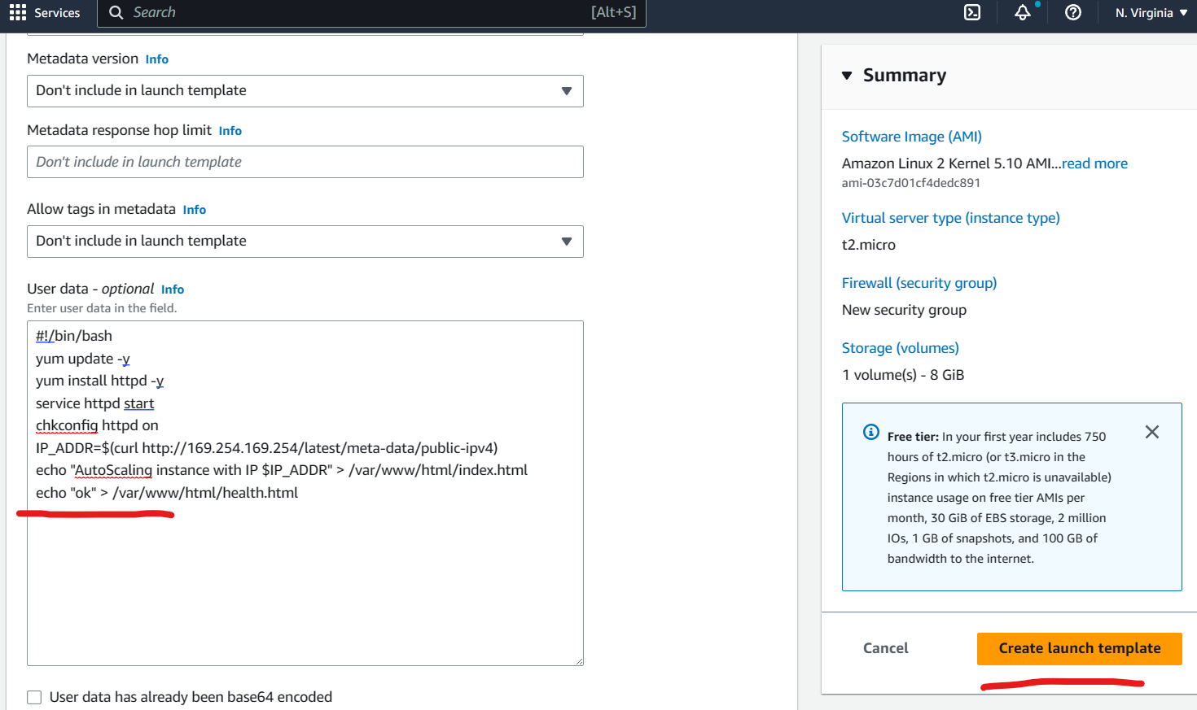  
Click on **Create Launch Template** .  
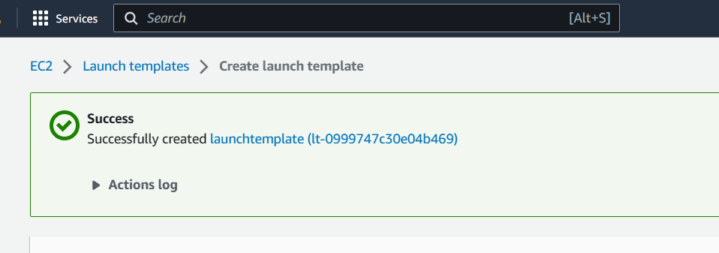

Congratulation you have successfully created a launch template  
  
Now you can visit the launch template list view   
select the launch template and click on **Actions** button and select **Create auto scalling** group.  
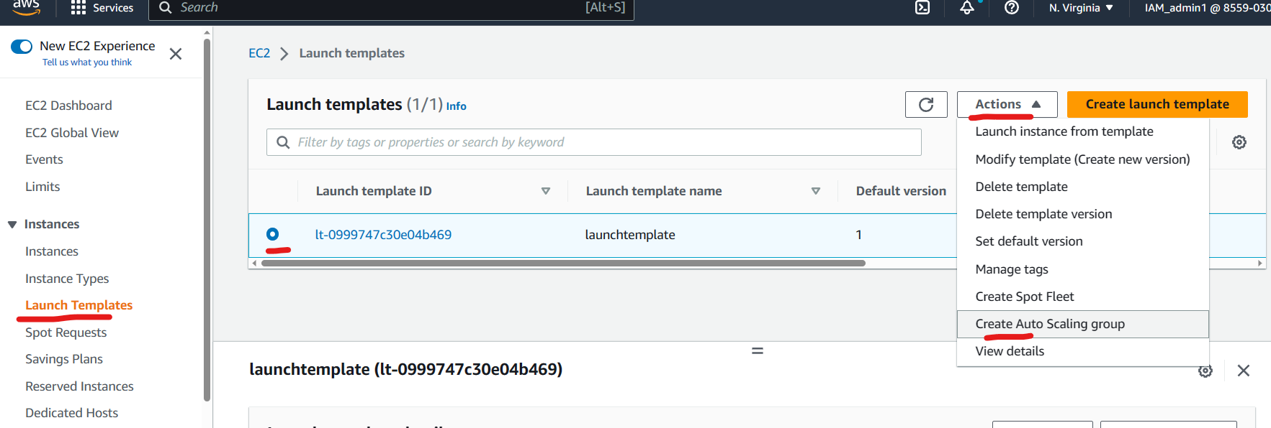

In the Auto scaling group form,  
fill up the name field and select the Template that you have recently created as shown below.  
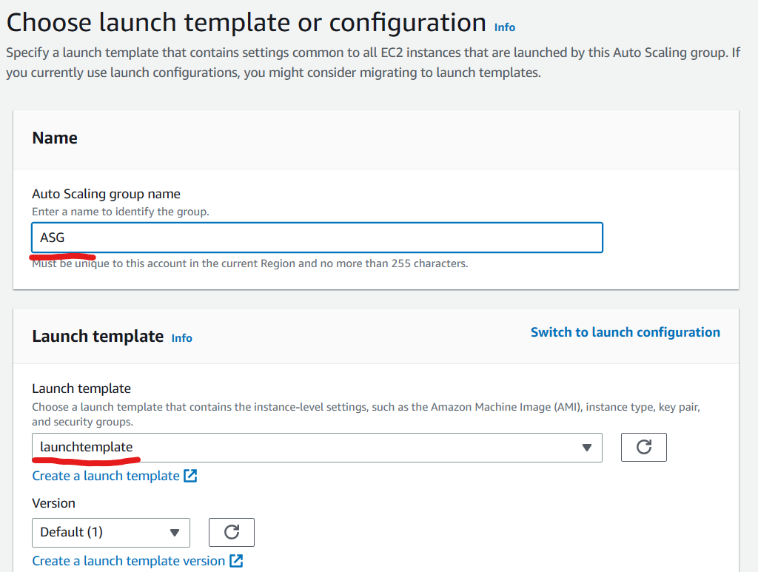  
Scroll down and click on **Next**.

In the “Choose instance launch options” page,  
Make sure that the VPC is selected.  
Tick mark all the availability zone as shown below.  
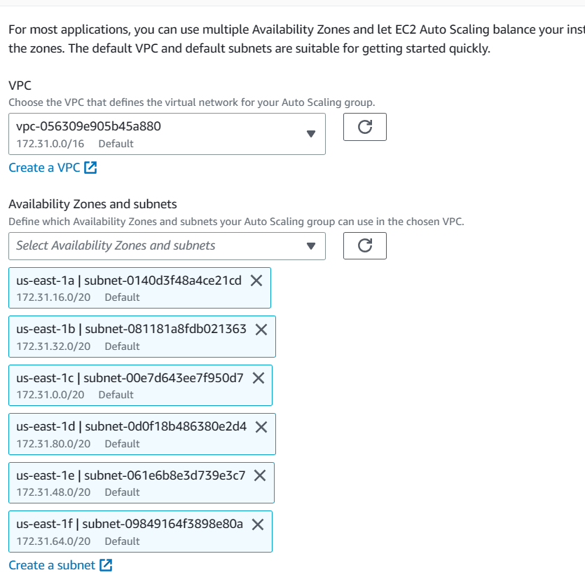  
Scroll down and click on **Next** .

Under Load balancing section  
Select “Attach to existing Load Balancer” and search for the target group which was recently created.  
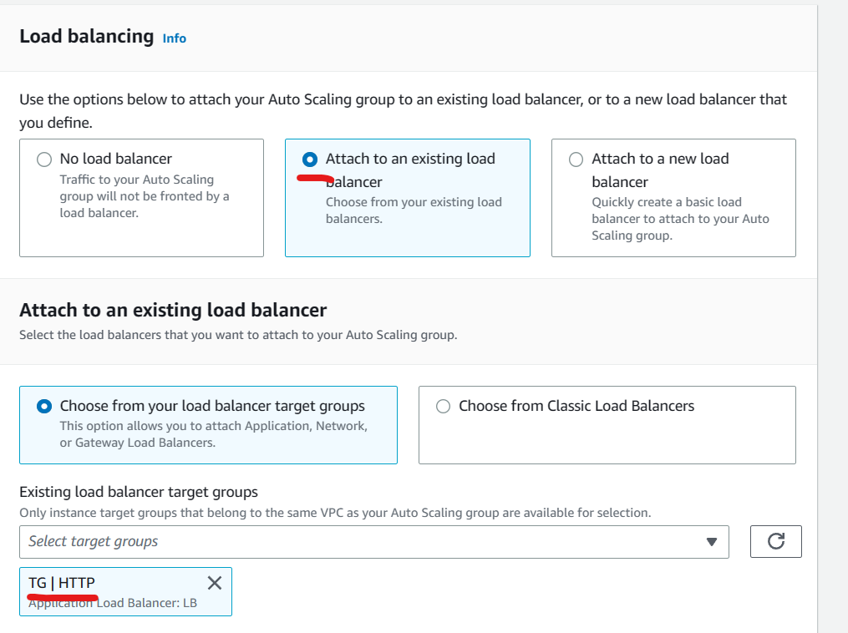  
Under Health check setup Health grace period to “10” as shown below.  
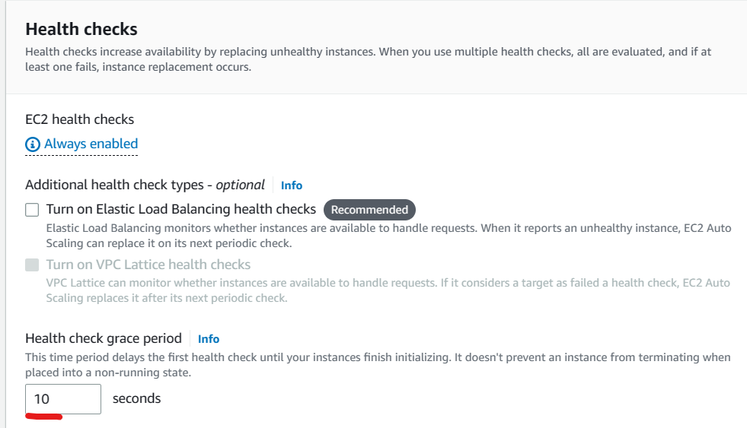  
Set Group size as follows  
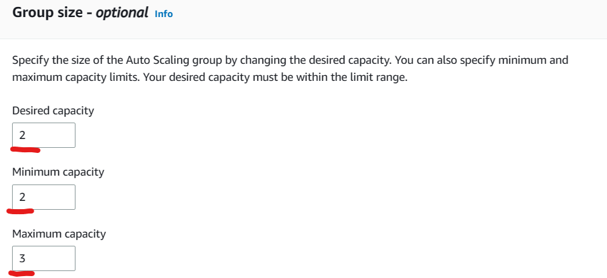  
  
Set Scaling policy as “Target tracking scaling policy”  
Set target value as 80. Set instance need to 10 seconds  
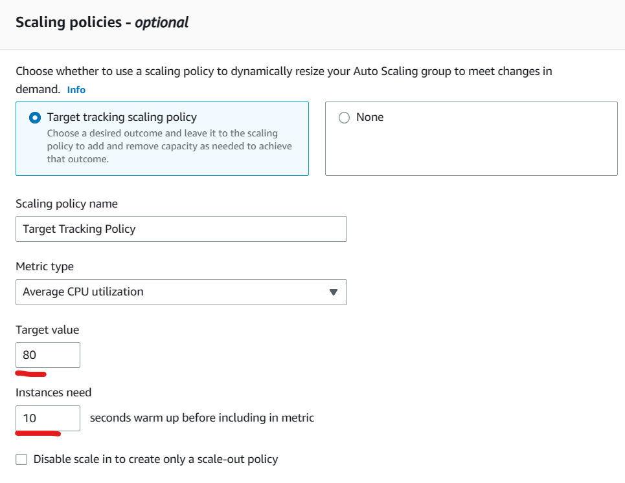  
Scroll down and click on **Next**.  
You will receive a “Add notifications” page .  
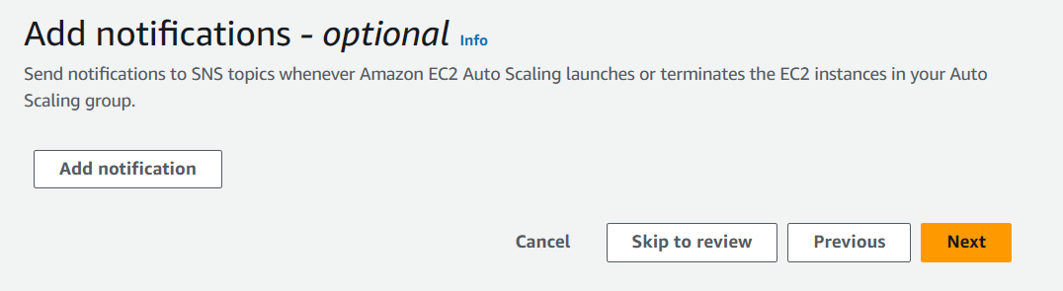

Click on  **Next.**Fill in the tag details as shown below.  
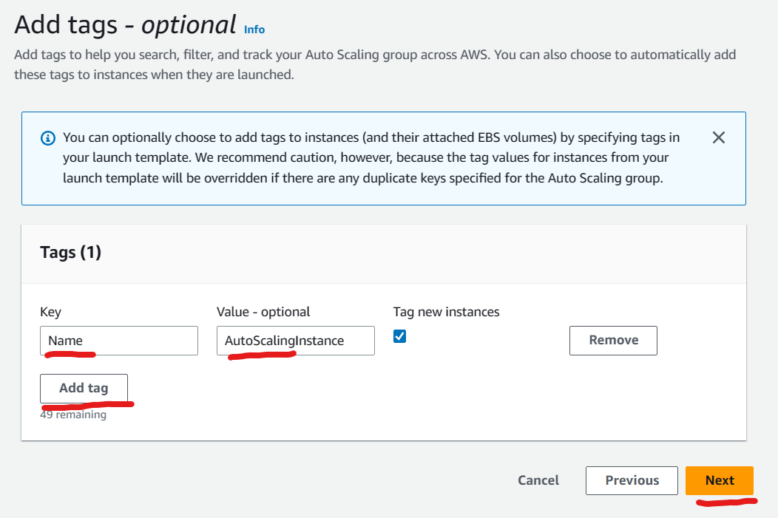

Click on  **Next.** You will arrive at the “Review” page.  
Review the setting and scroll down and click on **Create autoscaling Group**.

Congratulations you have successfully created a Autoscaling group.

On checking the Instance list menu, you will find 2 new instance created with the help of the launch template.  
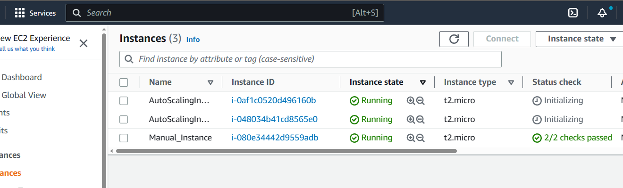

You can also find the instances added in the Target group as shown below.  
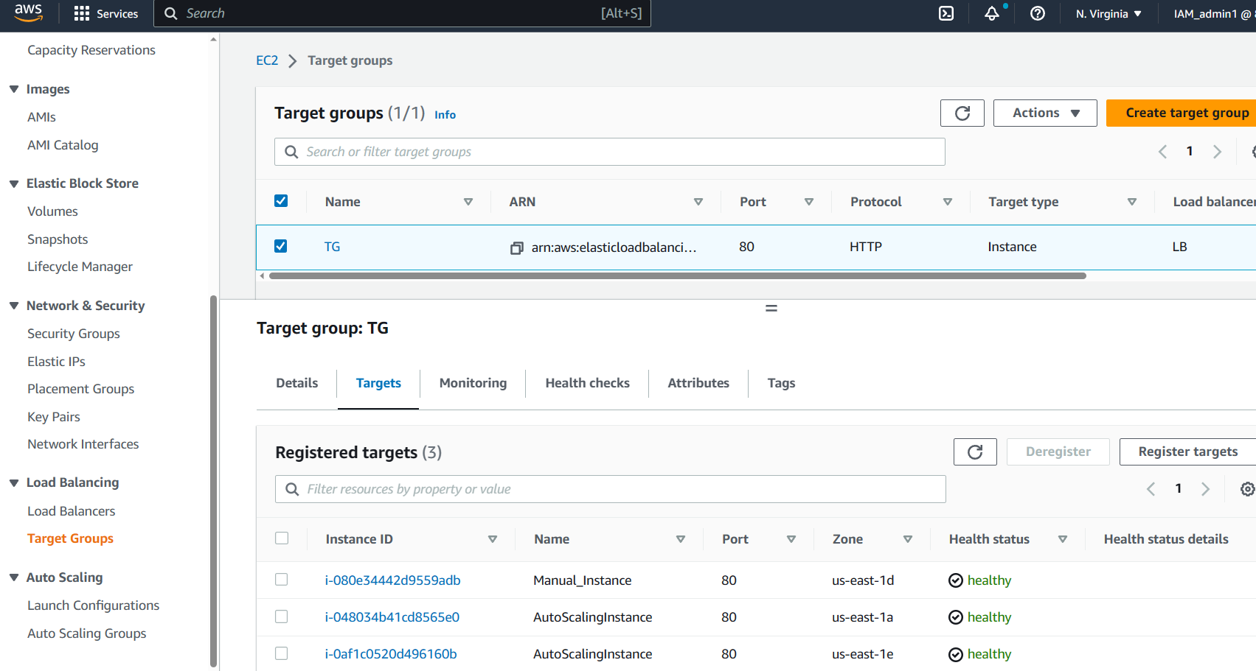

Now try Loading the DNS name from the Load balancer in the browser.  
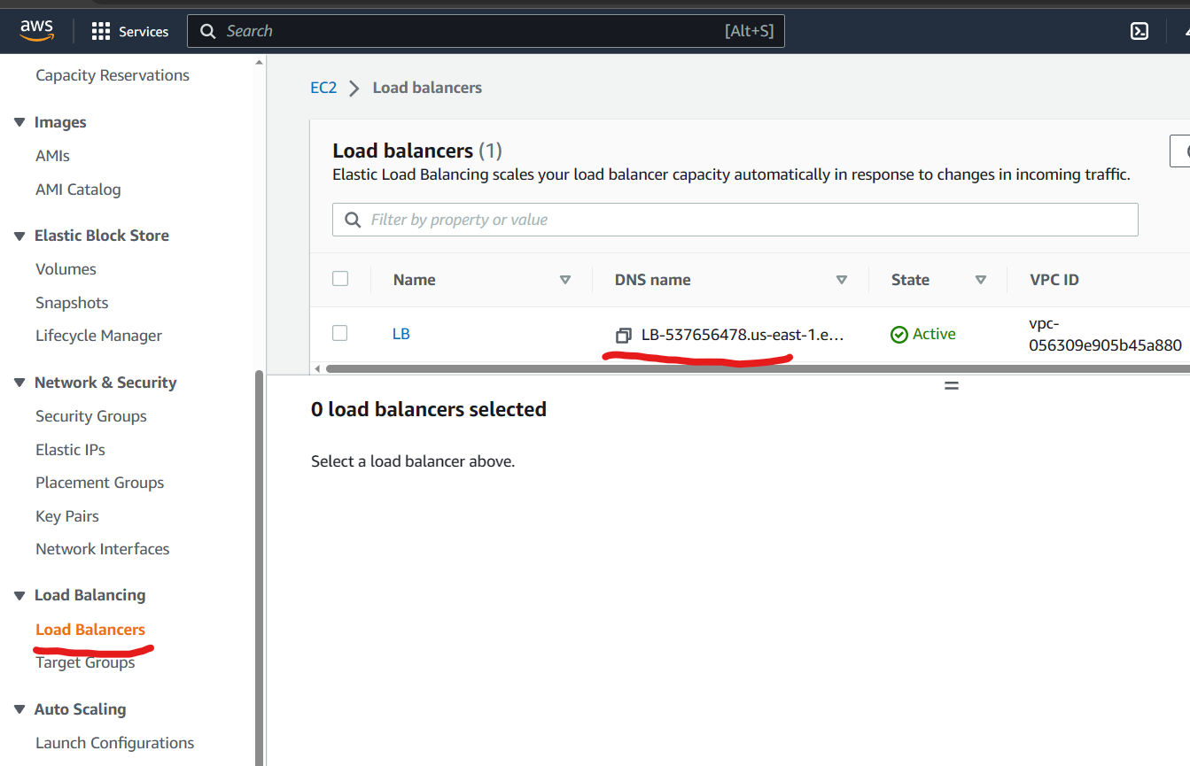

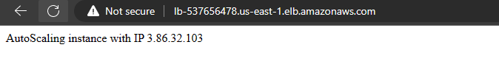

Relaoad the page repeatedly and you will notice that the traffic is routed to different instances as the ip address changes each time you reload.

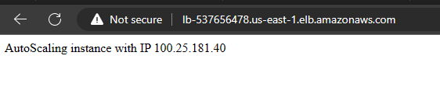  
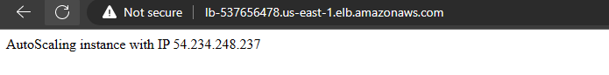

This means that the load balancer is functional on all 3 instances.

Now swtich to the Instance dashboard and stop the 2 instance created by the launch template.  
This done to check whether the autoscaling group will trigger a new instance.  
This would require some time to take action.  
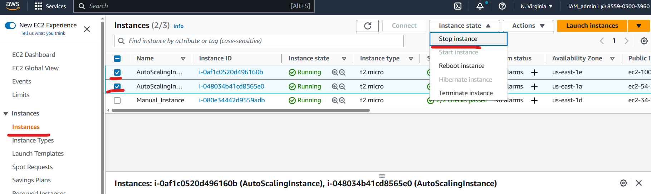

When the 2 instance have been stopped, the auto scaling group detects that minimum 2 instance active is not met and hence creates a new instance using the launch template.

After a short while you will notice a new instance created in the instance list as shown below.  
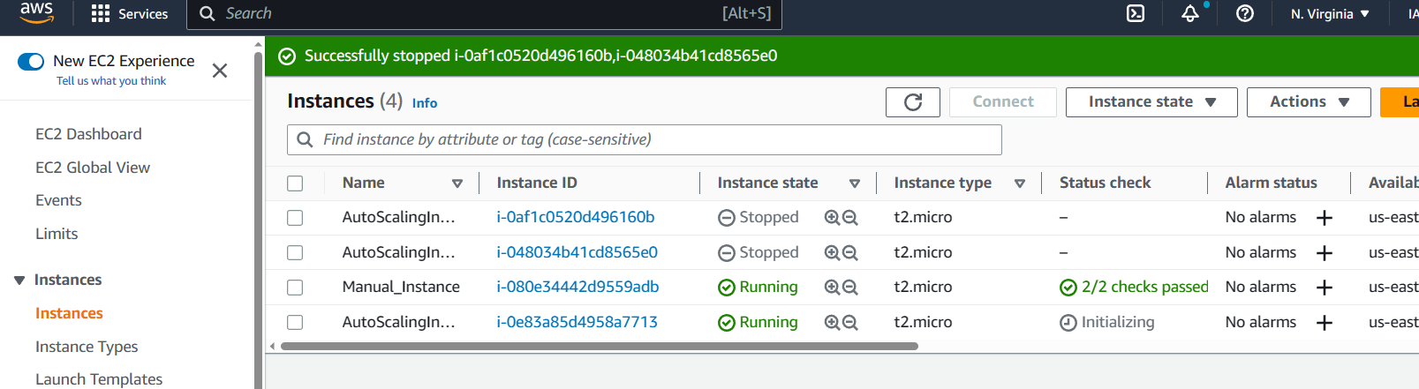

This means that the auto scaling group is also functional.

Clean up

Delete the Scaling group and load balancer before terminating the instance.

Click on Auto scaling group menue, select the Auto scaling group and click on delete button as shown below.  
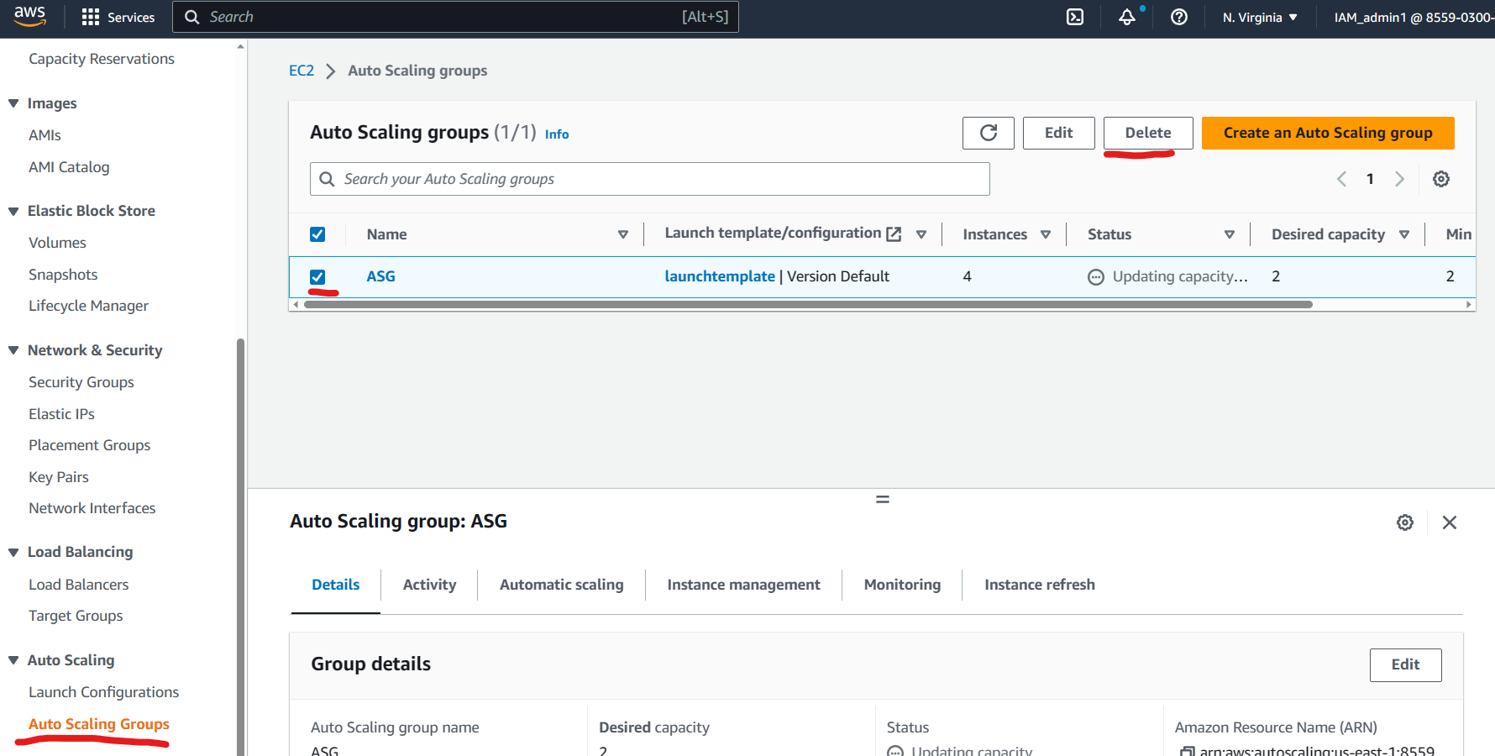

Type “delete” on the popup that appears and click on delete.  
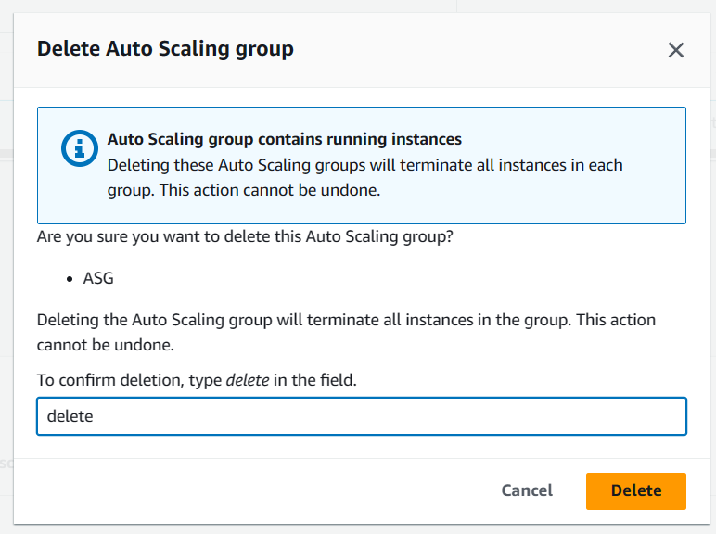

Similarly click on load balancer menu, select the Load balancer and click on  **Action** button as shown below.  
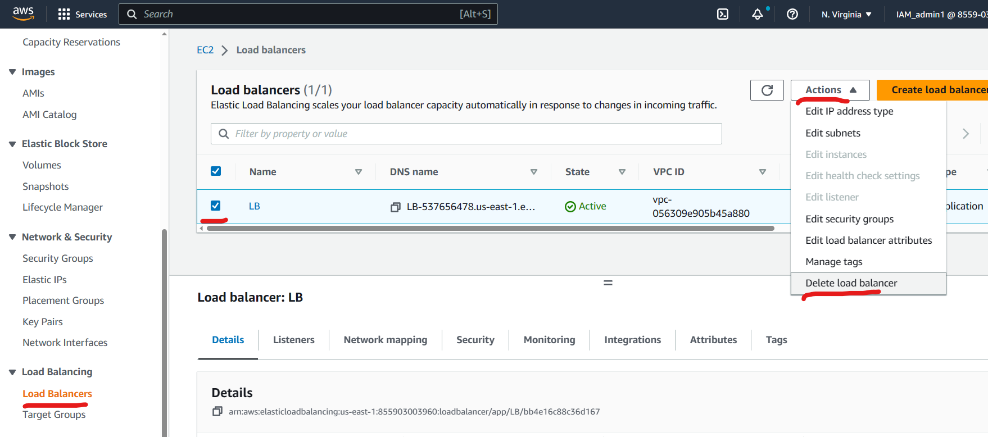

Select “Delete Load balancer”.  
type “Confirm” on the pop up page and click on **Delete**.

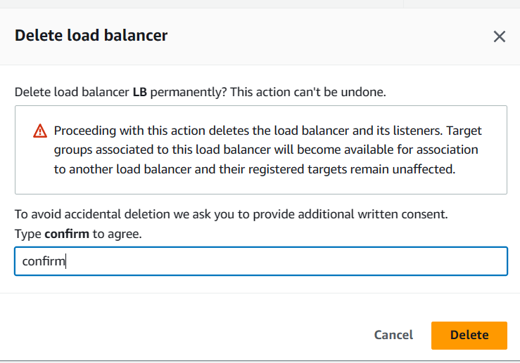

Similarly, click on **Target Group** , select the newly created target group.  
Click on **Actions** button and select  **Delete** as shown below.  
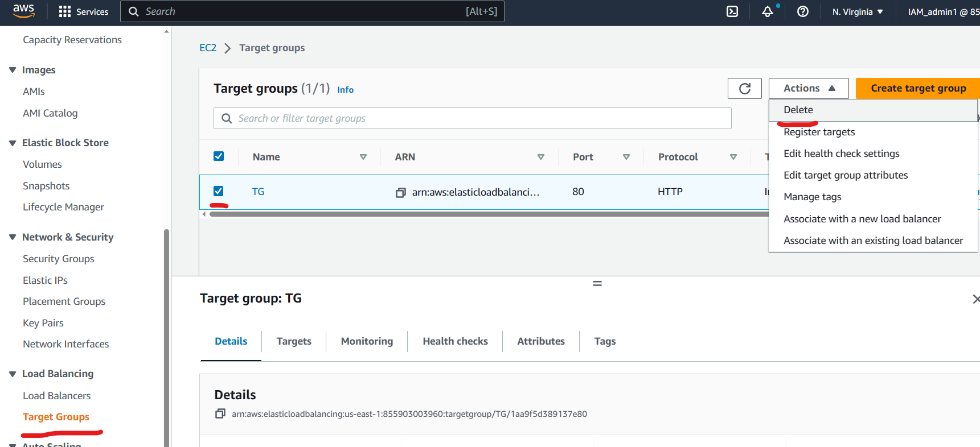

Click on “Yes Delete” on the pop up page.  
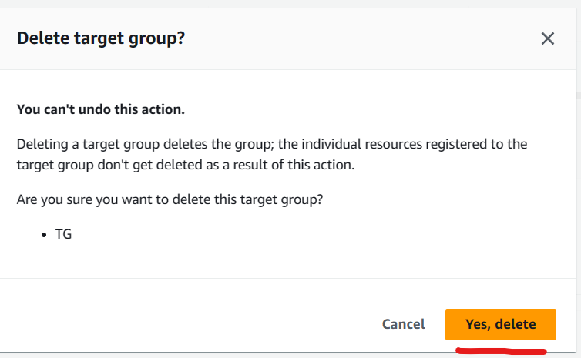

Now to terminate all the instances.  
Click on **Instances** and select all the instances.  
Click on **Instance state** and click on Terminate Instance as shown below.  
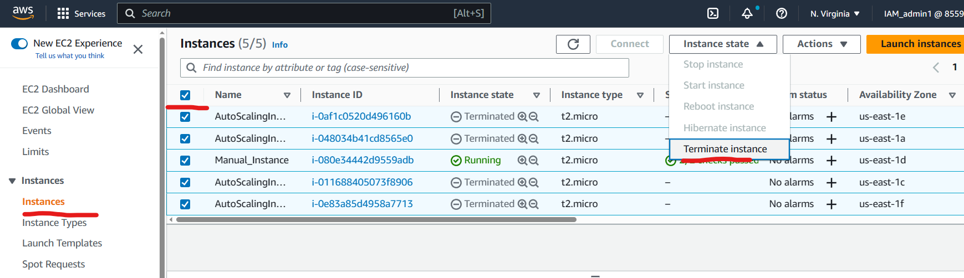  
Click on Terminate button on the pop up.  
